Assess Reserved Instance Candidates

Process diagram

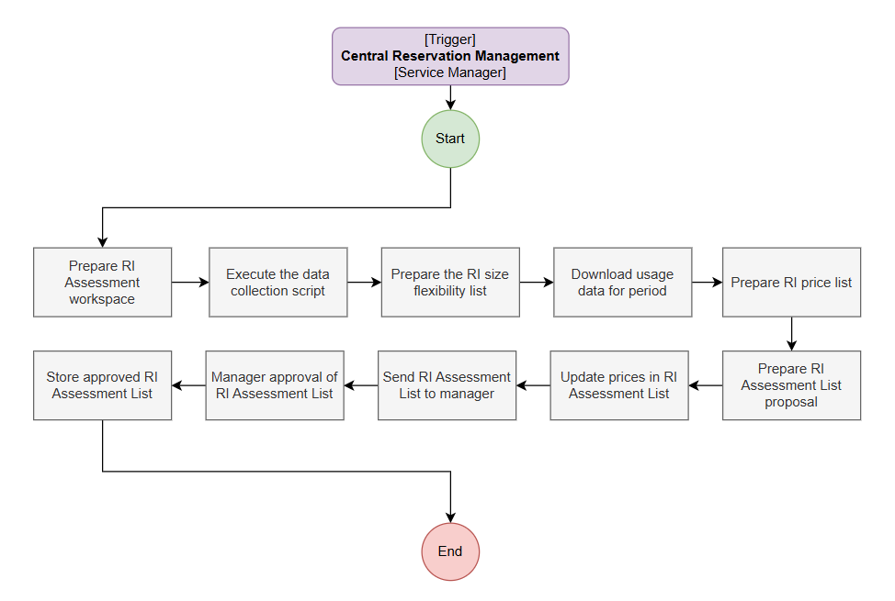

Prerequisites
- User account with…
  - Billing Profile Reader or Billing Account Reader if multiple profiles (View and download Azure usage and charges)
  - Owner or Reservation Purchaser RBAC rights for a Subscription (in order to view the reservation costs in Azure Portal for the assessment, Buy an Azure reservation - Microsoft Cost Management | Microsoft Learn)

Process steps
Note: This process assumes working knowledge of Power BI, PowerPoint and Excel. Steps are intended as guidance and do not detail every step exhaustively.
- Prepare RI Assessment workspace
  - Create a new working folder named "[date] - RI Assessment" (ex: "2025-12-02 - RI Assessment"). This folder will be the [RIAssessmentFolder]
  - Copy all files and folders from "Templates/MCA/Assess Reserved Instance Candidates" into the working folder
  - Create a new folder “Downloads” inside the [RIAssessmentFolder]. This folder will be the [DownloadsFolder]
- Execute the data collection script
  - Note: The data collection scripts periodically need to be updated to remove duplicate data etc. so be sure to understand them and be ready to modify them when required
  - Open a PowerShell terminal/console and execute the “run-collection-scripts.ps1” script (after reviewing and understanding the related scripts)
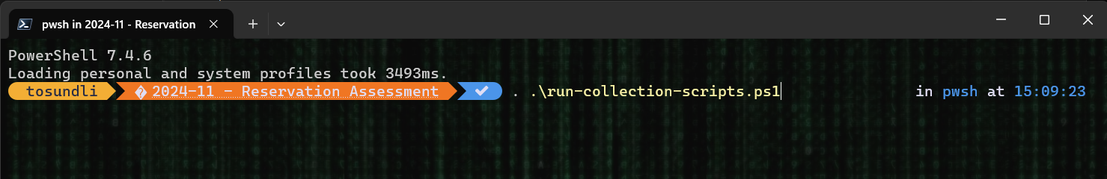
  - Will download…
    - Latest RI size flexibility list
    - Reservation Summaries
    - Reservation Transactions
- Prepare the RI size flexibility list
  - Open the “Downloadsisfratioblob.csv” file (reference link) in Excel and convert the csv rows into a table
  - Ensure all values in the “Ratio” column are treated as numbers (“.” vs “,”)
  - Save the file as an Excel file (=IFSRatio.xlsx)
- Download usage data for period (recommended last 12 months)
  - Open the Azure Portal in a browser
  - Go to "Cost Management + Billing", select the appropriate "Billing scope"
  - Select "Invoices" under the “Billing” section
  - For each month in the last year
    - Click "…" for the month in the rightmost column
    - Select "Prepare usage file"
    - Download CSV for "Usage Details" into the [DownloadFolder]
- Prepare RI price list
  - Open "RI Assessment List.xlsx" in Excel
  - Go to tab "Price Matrix" in the Excel sheet
  - Copy the columns "InstanceSizeFlexibilityGroup", "ArmSkuName" and "Ratio" from "IFSRatio.xlsx" into corresponding columns in the "Price Matrix" tab
- Prepare Power BI report
  - Open "RI Assessment Report...pbix" in Power BI Desktop
  - If you get a “Refresh” dialog, “Close/Cancel” out of it
  - Open "Transform data"
    - Ensure that the "RISize" query targets the table in the Excel "Price Matrix" tab from the file "RI Assessment List.xlsx"
    - Ensure that the "UsageDetails" query is updated so that it uses the [DownloadFolder] as its source for the CSV files
    - Ensure that the “reservation-summaries” query is updated so that it uses the JSON file with the same name in the [DownloadFolder] as its source for the CSV files
    - Ensure that the “reservation-transactions” query is updated so that it uses the JSON file with the same name in the [DownloadFolder] as its source for the CSV files
    - Close and apply the changes
  - Save the report as “.pbix”
- Prepare RI Assessment List proposal
  - Ensure that you have the Power BI report "RI Assessment Report...pbix" and the Excel file "RI Assessment List.xlsx" with tab "RI Assessment" open
  - Open the "RI Assessment List.pptx" template in PowerPoint
  - INFO: In the Power BI report there is a Slicer control with the title "Reserved Instance Group" at the top. This control filters the graph below based on selected Reserved Instance group
  - For each Reserved Instance Group in the Slicer that has data...
    - Ensure the Reserved Instance Group is selected in the Slicer to load the graphs
    - Prepare a new slide in the “Appendix” section for the Reserved Instance Group in the PowerPoint presentation
    - Make a screen clipping of the graph in Power BI and paste it into PowerPoint
    - From the graph, determine whether it would be reasonable to purchase Reserved Instances for any of the Regions...
      - If so, create a row in the Excel file and fill in "RI Series", "Region", "Potential Ratio" and “Existing Ratio” for each region and then copy the rows from Excel into the PowerPoint slide
- Update prices in RI Assessment List
  - Open the Azure Portal in a browser
  - Go to "Reserved VM Instances" (Azure Marketplace)
  - Ensure that "All Products" tab is selected
  - Select an appropriate "Region" (=West Europe?)
  - Remove the "Term" filter
  - Select "Upfront" for "Billing frequency"
  - For each row in the "RI Assessment" tab
    - Filter the table in the “Price Matrix” tab based the “RI Series” row
    - Fill in the “Price Matrix” columns for first “ArmSkuName” in the series…
      - Select the "One Year" row
        - Note the "Upfront price per VM" cost in the lower right and type the value into the corresponding field in the "Price Matrix" tab
        - Note the "Estimated savings" percentage in the lower right and type the value into the corresponding field in the "Price Matrix" tab
      - Repeat the above steps for the "Three Years" row
    - Fill in the “Reserved Instance Sku” with the “ArmSkuName” for the lowest Price/Ratio that you find for that size group
  - Prepare the initial PowerPoint slides based on the Excel sheet
- Send RI Assessment List to manager
  - Save the PowerPoint and Excel files in the [RIAssessmentFolder]
  - Send the PowerPoint and Excel files to the Service Manager for approval
- Manager approval of RI Assessment List
  - Review the PowerPoint and Excel files
  - Approve, reject and revise the proposed "Potential Ratio" numbers as appropriate in the Excel file
  - Save the modified Excel file
  - Notify the Service Operator about the results, share the updated Excel file (=[ApprovedRIAssessmentList]) and initiate the "Create Reserved Instances" process
- Store approved RI Assessment List
  - Store the [ApprovedRIAssessmentList] in the [RIAssessmentFolder]

Process outputs
- [ApprovedRIAssessmentList]
  - The Excel file with details on the Reserved Instances that are approved for purchase

